**Upgrade/Patch a linux machine with latest version**

Below steps will help to upgrade to a higher version.

1. vi patchupdate.sh
2. chmod +x patchupdate.sh

#!/bin/bash

echo "your current Amazon Linux Extras kernel version is:"

uname -r

echo "available kernel version to update is:"

sudo amazon-linux-extras |grep kernel

echo "Please enter which kernel version you want to enter:"

read ver

sudo amazon-linux-extras install ${ver} -y

sudo reboot

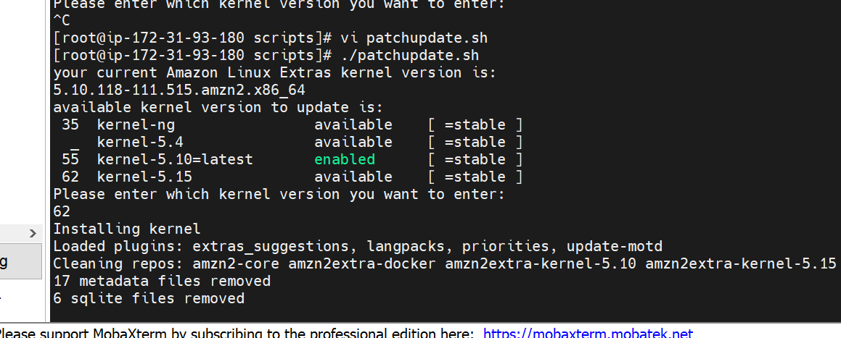

You will be rebooted and when again restarted will be updated with latest linux version

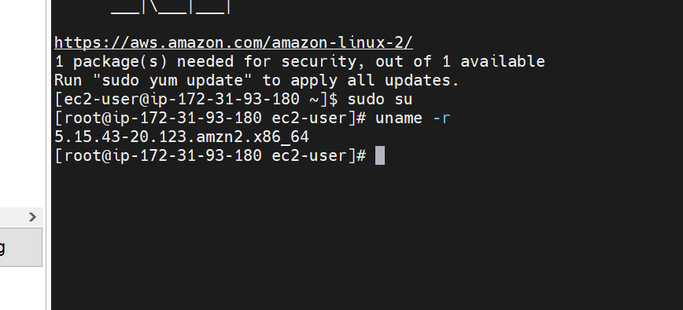

**For Live patching**

* Install binutils, kernel

sudo yum install binutils

sudo yum list kernel

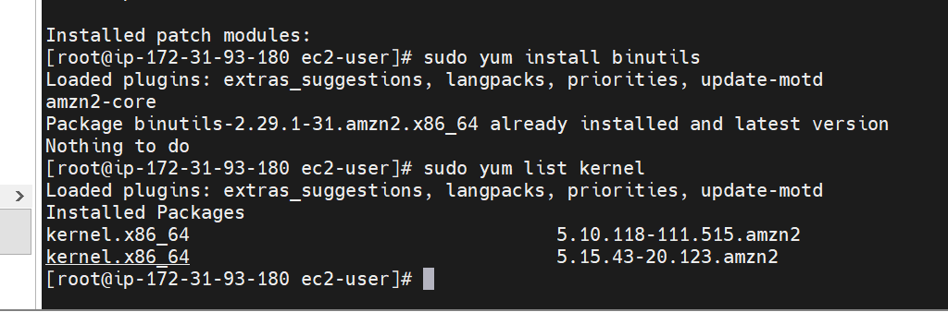

1. Create a file name livepath.sh and copy below command

#!/bin/bash

sudo yum install -y kernel

sudo reboot

sudo yum install -y yum-plugin-kernel-livepatch

sudo yum kernel-livepatch enable -y

rpm -qa | grep kernel-livepatch

sudo yum install -y kpatch-runtime

sudo systemctl enable kpatch.service

sudo amazon-linux-extras enable livepatch

yum updateinfo list

yum updateinfo list cves

sudo yum install kernel-livepatch-kernel_version.x86_64

sudo yum install kernel-livepatch- 5.15.43-20.123.amzn2.x86_64

sudo yum update –security

